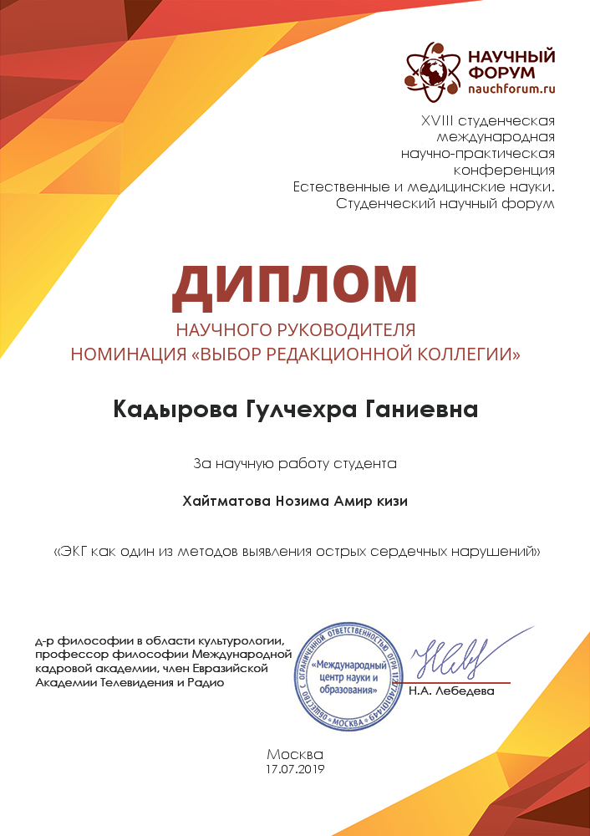

[logo of the Scientific Forum]

XVII student international

scientific and practical conference

Natural and medical sciences.

Student Scientific Forum

**SUPERVISOR DIPLOMA**

Nomination

"Choice of the Editorial Board"

**Kadirova Gulchekhra Ganievna**

for the student's scientific work

**Khaytmatova Nozima Amir kizi**

“ECG as one of the methods

for detecting acute cardiac disorders”

Doctor of Philosophy in Culturology,

Professor of Philosophy at the

International Personnel Academy,

Member of the Eurasian Academy of */stamp/ /signed/*

Television and Radio N.A. Lebedeva

Moscow

17.07.2019